ISM 3232 Final Exam Lab
INSTRUCTIONS:
Complete the steps below. Make sure you “Run” your project when you are finished to make sure that it works and view the quality of the interface prior to turn it in. Make sure that you close your project when you are ready to turn it in and ZIP the entire project directory so that all files are uploaded to CANVAS.
DELIVERABLES:
- For this lab you will be creating the Graphical User Interface (GUI) shown below:
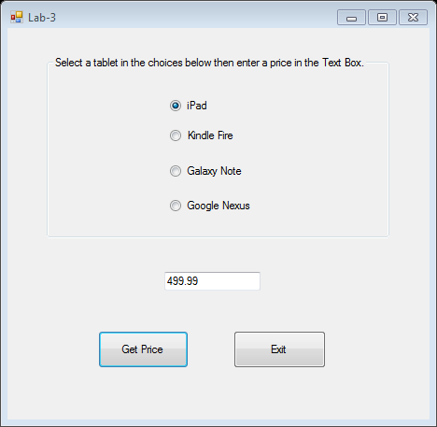
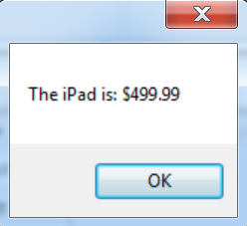
- The user will select a Tablet from one of the Radio Buttons and enter a price in the text box below. Once the user clicks the “Get Price” button, the application will display a Message Box similar to the screen shot seen above.
- If the user enters bad data (for instance when they enter letters instead of numbers) they should be presented with a Message Box similar to the below: (“You have an error!”).
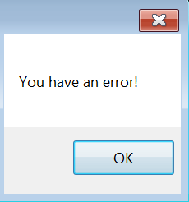
- (1 Point) Open Visual Studio and create a new Window Application Project. Name the Project FinalExam. NOTE: Ensure that C# is the programming language selected.
- (1 Points) Make sure the form is named FinalExam. Change the Forms Text property to “Final Exam”. Re-size the form to Height = 700 and Width = 700.
- (10 Points) Setup the applications form as shown in the screen shot above. As you place each of the controls on the form, refer to the following:
Control Name | Control Type | Property Settings
groupBoxTablets | GroupBox | Text: Select a tablet in the choices below then enter a price in the Text Box.
radioButtonIpad | RadioButton | Text: iPad  Checked: True
radioButtonKindleFire | RadioButton | Text: Kindle Fire  Checked: False
radioButtonGalaxyNote | RadioButton | Text: Galaxy Note  Checked: False
radioButtonGoogleNexus | RadioButton | Text: Google Nexus  Checked: False
textBoxPrice | TextBox
buttonGetPrice | Button | Text: Get Price
buttonExit | Button | Text: Exit

- (10 Points) Add code to the buttonGetPrice that will do this following when the user clicks:
  - Create a Try and Catch block statement to store the code and trap the error if one occurs.
  - Declare a double variable called Price
  - Then set the value of the Price variable to the text value in the textBoxPrice
    - NOTE: you will need to Parse the string stored in the text box to an double in order to successfully store and assign the value in the textBoxPrice to the double Price variable
- (30 Points for the If/else if/else statement) Continue to add the following to the buttonGetPrice. Create an If/else If/else statement to support the application. When a user selects a radio button, types a price, and then clicks the “Get Price” button a Message Box should appear with the appropriate Tablet with price (as seen in the screen shots above)
  - The pseudo code of the If/else if/else block of code will look like the following:
If the user clicks the radioButtonIpad
Show a message box with the IPad Price
Else if the user clicks the radioButtonKindleFire
Show a message box with the Kindle Fire Price
Else if the user clicks the radioButtonGalaxyNote
Show a message box with the Galaxy Note Price
Else
Show a message box with the Google Nexus Price

Here’s a sample of what SOME of the C# Code might look like:

if (radioButtonIpad.Checked)
{
MessageBox.Show("The iPad is: $" + Price);
}
else if (radioButtonKindleFire.Checked)
{
MessageBox.Show("The Kindle Fire is: $" + Price);
}

  - Display a string in a Message Box similar to the following (See screenshot on Page 1):
    - “The XXXXX is: $XXX.XX”
  - Finally, make sure you include a Message box that pops up and says, “You have an error!” if the user enters bad data (in case the user enters a string in the textBoxPrice text box).
- (3 Points) Add code to the buttonExit button that closes the application
- Run your program to make sure that it works as expected.
- Close your project and ZIP your entire project file. Then upload your project to CANVAS.

